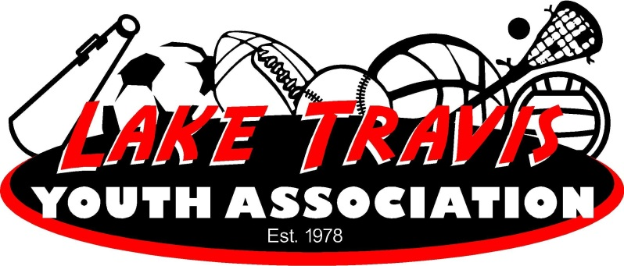

LTYA T-ball & Baseball (excludes WEE Ball)
Equipment Needs

LTYA T-ball and Baseball players - players are responsible to bring their own helmet (any color), baseball glove, cleats/sneakers (most players wear cleats), bat and pants. Pants color is team dependent and cannot be purchased until team assignments are made.

Bats – PLEASE REFER TO THE LTYA BAT RULES POSTED UNDER THE RULES SECTION OF THE BASEBALL PAGE AT WWW.LTYA.ORG

LTYA Provides Players – a jersey/shirt, hat, belt and socks.

LTYA Provides each Team Coach– Catchers gear, 1 dozen practice balls and 1 dozen game balls. LTYA provides T-ball teams a Tee as well.

NOTES: There are usually lots of bats on most teams so generally a player can find one to use when batting instead on buying one.

Players are responsible for bringing their own water/drinks to games and practices so many folks buy water jugs.

Coaches we do not provide score books so if you want to keep your score in an official score book please buy one.

